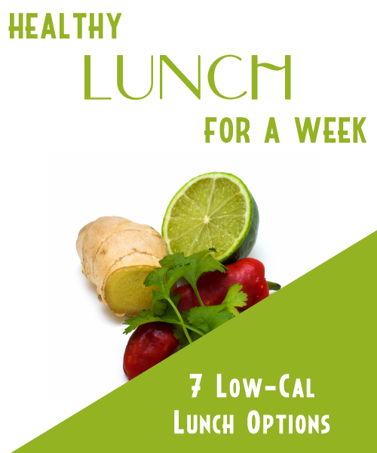
Table Of Contents

Pasta & Beans 3

Turkey Reuben 3

The Healthy Roti 3

Sesame Noodles With Chicken 3

Mexican Lunch Minus The Meat 3

Healthy Lunch Pizza 3

Grilled Veggies 3

Pasta & Beans

This hearty dish combines filling beans with delicious pasta.

Ingredients

1 1/2 tbsp extra virgin olive oil
1 onion, chopped
2 tomatoes, chopped
1 (15 ounce) can beans
2 cups penne pasta
salt to taste

Directions

1. In a frying or saute pan heat the oil. Add onion and then cook until translucent. Add tomatoes and beans. Let simmer for 10 mins.

2. Bring a large pot of lightly salted water to a boil. Add pasta. Cook until al dente then drain.

3. Mix pasta with bean mixture, toss to coat.

(Makes 4 Servings)

Calories Per Serving: 286

Turkey Reuben

This healthy version of the Reuben sandwich still packs some great flavor.

Ingredients

1/4 Cup Fat-free Thousand Island Dressing
8 Slices Whole Wheat Bread
8 oz. Low Sodium Turkey Breast
1/2 Cup Sauerkraut (rinsed and drained)
4 Slices Reduced Fat Swiss Cheese
Olive Oil Cooking Spray

Directions

1. Spread dressing on one side of each slice of bread.

2. Stack sandwiches with turkey, sauerkraut and cheese.

3. Spray a large pan with olive oil spray and cook 2 sandwiches over medium heat for 4 minutes per side. Make sure bread is toasted and cheese is melted then serve hot.

(Makes 4 servings)

Calories Per Serving: 268
The Healthy Roti

Experience the Caribbean with this West Indies inspired dish.

Ingredients

1 tsp vegetable oil
1 small onion, peeled and sliced
1 cup chicken or vegetable broth
1 sweet potato, peeled and cubed
1 clove garlic, minced
1/2 tsp cumin
1/4 tsp each coriander, cinnamon and turmeric
1/2 tsp hot sauce
1 cup canned chickpeas
1/4 cup coconut milk
2-3 large roti or wheat flour tortillas

Directions

1. Heat oil in a non-stick pan over medium heat. Add the onion; cook for 5 minutes. Stir in broth, sweet potato, garlic, cumin, coriander, cinnamon and turmeric.

2. Cover and cook, stirring ever so often for 15 minutes or until potato is tender. Season with hot sauce.

3. Stir in chick-peas and coconut milk. Bring to a boil. Cook, stirring often, until chick-peas are heated through. Divide mixture between two roti shells. Roll to make a wrap.

(Makes 2 to 3 servings.)

Calories Per Serving: 353
Sesame Noodles With Chicken

Harness the flavor of sesame in this asian inspired dish.

Ingredients

1 bag Japanese buckwheat soba noodles
5 tbsp low-sodium soy sauce
2 tbsp rice wine vinegar
1 tbsp sesame oil
2 tbsp honey
2 tsp honey mustard
1 tbsp creamy peanut butter
3/4 lb boneless, skinless chicken breast
5 scallions

Directions

1. Cook noodles according to package.

2. In a large bowl whisk together next 6 ingredients to make dressing.

3. Cook chicken until cooked through. Shred and add to peanut mixture.

4. Add drained noodles, scallions and toss until combined.

(Makes 4 Servings)

Calories Per Serving: 208
Mexican Lunch Minus The Meat

This tasty vegetarian dish is sure to please even the pickiest meat eater.

Ingredients

1/2 small onion, chopped
1 can (15 1/2 ounces) crushed tomatoes
3/4 cup frozen corn kernels
1 can (3 1/2 ounces)chopped green chile peppers
1 can (14-19 ounces) black beans, rinsed and drained
1/2 cup instant rice
1 tsp ground cumin

Directions

1. Heat a 2-quart pot coated with cooking spray over medium-high heat. Add the onion and cook, stirring, for 1 minute. Add tomatoes, corn, and chile peppers

2. Bring to a boil.

3. Add the beans, rice, and cumin. Remove from heat, cover, and let stand for 10 minutes.

(Makes 4 Servings)

Calories Per Serving: 199
Healthy Lunch Pizza

This version of pizza packs all the flavor of take out, but a mere percentage of the calories.

Ingredients:

1 toasted whole wheat pita
1/2 Cup chopped tomatoes
1/4 Cup shredded part-skim mozzarella
1/2 Cup grilled chicken breast
1/4 Cup chopped sun-dried tomatoes
Garlic and Oregano to taste

Directions

1. Top 1 toasted whole wheat pita with tomatoes, mozzarella, grilled chicken breast, and chopped sun-dried tomatoes.

2. Sprinkle with minced garlic and oregano

3. Place under oven broiler until cheese bubbles.

Calories Per Serving: 367.8
Grilled Veggies

This meal could be a dinner it is so filling. Quick enough for lunch though.

Ingredients

1/3 cup balsamic vinegar
1 tbsp Dijon mustard
3 garlic cloves, minced
1 tsp fresh rosemary, chopped
1/4 cup extra-virgin olive oil
1 red onion
2 zucchini
2 yellow squash
12 oz asparagus, trimmed
1 roasted red bell pepper
1 1/2 cup lightly packed arugula, chopped
1 cup mixed baby greens
2 tbsp fresh parsley, chopped

Directions

1. In a medium bowl, whisk first 4 ingredients to make the dressing. Gradually add oil while stirring fast.

2. Heat barbecue or pan to medium high.

3. Brush onion, zucchini, yellow squash, and asparagus with 1/2 of the balsamic dressing. Grill or saute vegetables until just cooked through, turning occasionally.

4. Allow veggies cool slightly, then cut into small pieces and place in large bowl.

5, Add roasted bell pepper, arugula, and greens; toss with enough dressing to coat.

(Makes 4 Servings)

Calories Per Serving: 194

